**Child Tracker With Emergency Notifications Using IBM Cloud**

A Project Report Submitted

as part of the Smartbridge Externship

Internet of things (IoT)

by IBM

Submitted By :

DEEPAK.M.M

GOWTHAM.P

HARISH RAGHAV.S

JEYVARSHA.S

**INDEX**

|  |  |  |  |
| --- | --- | --- | --- |
| **S.No.** | | **Table Of Contents** | **Page No.** |
| 1 | | Introduction |  |
|  | a | Overview | 2 |
| b | Purpose | 2 |
| 2 | | Literature Survey |  |
|  | a | Existing Problem | 4 |
|  | b | Proposed Solution | 5 |
| 3 | | Theoretical Analysis |  |
|  | a | Block Diagram | 6 |
|  | b | Hardware/Software Designing | 7 |
| 4 | | Experimental Investigation | 7 |
| 5 | | Flow Chart | 8 |
| 6 | | Result | 8 |
| 7 | | Advantages and Disadvantages | 9 |
| 8 | | Applications | 10 |
| 9 | | Conclusion | 10 |
| 10 | | Future Scope | 11 |
| 11 | | Bibliography | 11 |
| 12 | | Appendix |  |
|  | a | Source Code | 12 |
| b | UI Output Screenshot | 14 |

**1.Introduction**

**a. Overview:**

People cannot predict or determine what will happen the next moment. Due to this uncertainty people could make some arrangements to prevent it. As the parents are considered, their greatest concerns are their children, especially regarding the safety of the child. The parents start to take care of the children since born. The parent is not possible to always stay beside of them as most of the parents are in need to go for work to run a sustainable family. At that point of time they are very much anxious about their child’s activity each and every moment. Today’s child is easily influenced by their friends and there are several possibilities to even get missed or to be kidnapped by any of the strangers, as what had happened to a girl, named NurlinJazlin, who had gone missing on August 20, 2007 after she went alone at a night market in Kuala Lumpur . So To minimize this tragedy from happening again, an action needs to be taken to deal with this problem. Thus, in order to resolve these problems the child tracking system is proposed

**b. Purpose:**

Child tracking system is an app that can track and monitor the child location. The aim of the project is to create a system to allow the parents to keep track of their kids when their child is out of their view. This is mainly designed to monitor child’s safety and security when they are left alone. The children, growing up bring with them a mixture of pleasure and pain, love of knowing every thing and need to discover any thing. It would be nice if children are happy and free of troubles or dangerous. Feeling safe about children is the first important needs for parents in all worlds. Although there is no substitute for good childcare, which would include constant monitoring, the reality is that constant monitoring of children is not always feasible.

**2.Literature Survey**

**a. Existing problem:**

* **Crossbow Motes technology :**

Crossbow Motes are very small devices that contain a microprocessor, radio transceiver, and interfaces to connect simple sensors such as smoke, temperature.etc.,

These Motes are a new and quickly-growing technology. But there are some disadvantages to use these devices such as: Finite Coverage, affected by trees & walls High cost.

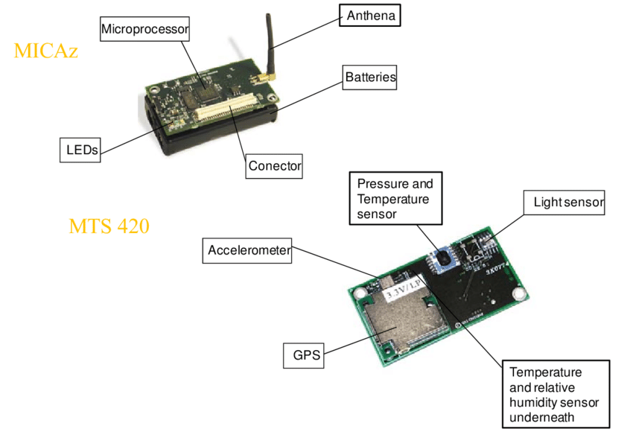

* **Gotcha System :**

Gotcha it is child monitor that helps parents to protect their children at malls, supermarkets, parks, or everywhere. Gotcha alerts the children and parent whenever they wonder farther than a safe distance. Gotcha is an invisible electronic leash between parents and their kids. Gotcha Simply attaches the child unit to the little one, and turned on the system from the parent unit. Child unit will alarms if the child has wandered beyond the adjustable, predetermined safety perimeter that the parent set the child's unit triggers an alarm to sound if the unit is removed or accidentally falls off. Gotcha is a pager too, simply press the locate button on the parent unit and the Gotcha child unit will beep. But the main disadvantage of using this system that it doesn’t monitor the type of danger which can be used with multi-child.

**b. Proposed solution:**

Our project is aimed to help locating missing or lost children. Many of today’s children have smart phones which is convenient for this kind of situation. In this work, GPS is combined with one of the basic service of a smartphone, more specifically SMS, in one system. Information such as GPS coordinates and time are gathered and sent to the parent smart phone that’s preregistered on the application. The correspondence between the parent and the kid applications is finished utilizing Short Message Service (SMS).SMS offers the system unique features. The system sends the location of child’s smart phone to parent’s smart Child Tracker With Emergency Notifications Using IbmCloud.

So our proposed Child tracker helps the parents in continuously monitoring the child's location easily and in a economical manner . They can simply leave their children in school or parks and create a geofence around the particular location. By continuously checking the child's location notifications will be generated if the child crosses the geofence. Notifications will be sent according to the child's location to their parents or caretakers. The entire location data will be stored in the database.

**3. Theoretical Analysis**

**a. Block diagram :**

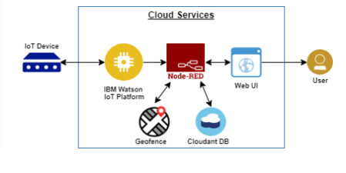

**b. Software designing:**

In this project we are using python code to generate Random Sensor values that is the live GPS location { Latitude and longitude } . From the python code these sensor values will be sent to the IBM IOT platform. Then using the NODERED service we have integrated IBM IOT, Cloudant DB and Geofence into it.

So once we get the live location of the child from the IBM cloud ,it will be analysed and verified by the Geofence node. Then if the child is in case out of the Specified Geofence latitude and longitude an emergency alert will be sent across the FAST2SMS platform to caretaker’s mobile phone as notification . And also All these cloud connections are done in NODE-RED. This node-red provides different dashboard nodes to view the interface in the WEB UI .The cloud which we are using in this project is IBM cloud .the GPS locations are recorded and stored in the cloudant Database .

**4. Experimental Investigations:**

A system was developed using IBM cloud node red service and fast2sms service. The developed system was experimented by running python code which will publish the location information (latitude and longitude) to the cloud. But in real world this data can be location data of child’s mobile phone. It is tested that if the child is out of specified geofence area, then an sms is received to child’s parent mobile number or the configured mobile number using fast2sms service the next moment.

**5. FLOWCHART**

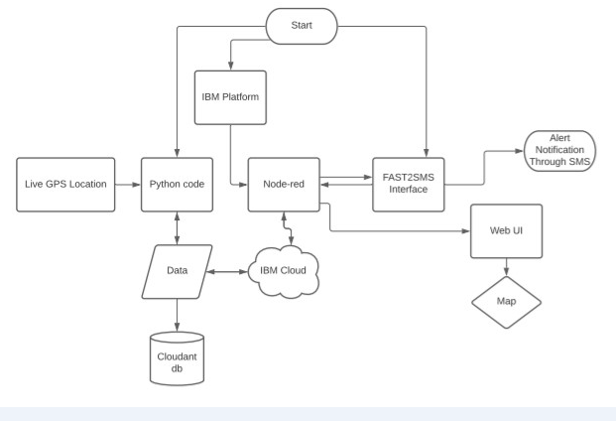

**6. Result**

The child is monitored through his/her GPS location. Parents here will fix a geofence and it is turned on for monitoring the child’s safety. The child is left out free and we here are able to locate the child’s location when ever needed. The data are getting stored in the cloud and it could be fetched at any point of time. And if the child has crossed the geofence area an alert message is sent to the configured mobile number quickly. So this helps us to monitor the child’s safety.

**7. Advantages & Disadvantages :**

**Advantages:**

1. Free and Independent Operation

2. Global Accessibility

3. Commercial and Scientific Applications

4. Civilian and Personal Applications

5. Prevent abduction and let your children play and walk around safely. Our child trackers are great options for parents for monitoring their children 24/7. Our device can track a children’s location as well as allow parents to set up a safe zone for their kids.

6.Peace of mind for parents

7.Location tracking can also be reassuring for the child, particularly if they get lost - this is especially useful if a child wanders off in a crowded place.

**Disadvantages:**

1. Issues Concerning Accuracy

2. Dependent on Battery Life

3. Concerns About Privacy

4. Young people run the risk of **not** learning to be ­independent and safe on their own.

5. Children need a smartphone for their parents to install a tracking app, but this can expose them to the potential dangers associated with social media and the internet such as cyberbullying, inappropriate contact with strangers and unsupervised access to inappropriate information.

**8. Applications**

Our project can be applied to track a child. We have built in a way so that we could get a notification to our mobile when the child is out of the given geofence location. It could be used in places were the child is left free. This tracker will continually update the child’s location on the server that can be accessed by the parent. It is also designed to alert parents in case of any emergency situation or any deviation in the set plan. Parents can breathe easy knowing that they have a constant tab on their child’s location. So, even if the child doesn’t pick up the phone or truthfully tell their exact location, parents will be able to correctly find out where they are and determine how long they will take to reach home.

**9. Conclusion**

It is concluded that the system is reasoned that the framework is to give youngster’s security by the parents. This work is intended for guardians and kids. The child can have a smart watch and the parent should have an smart phone that bolsters GPS and SMS as a base. SMS is a fundamental administration on any advanced cells yet GPS can be found on smart phones. This application is for the most part to be utilized by guardians to find the youngster's area and guarantee their versatile utilization to identify undesirable activity on the portable. The application is utilized to follow the Child's area and their security.

**10. Future Scope**

At long last, similar to any product item or configuration, there is still space for improvement. Highlights can be added to upgrade the framework, for example, crisis cautions and numerous others. The IMEI number parameter can be added to this system make it more efficient .The proposed system will be implemented, continued, reviewed and improved in a later work.

**11. Bibliography**

<https://www.google.com/search?sxsrf=ALeKk026vqAQdudLLgEVAdsk5cu4ViJ0QA:1627789860798&q=GPS+tracker+for+kids&sa=X&ved=2ahUKEwiVwq_j9Y7yAhXZR30KHQpuCH0Q1QIwCnoECAcQAQ&biw=1366&bih=657>

<https://www.irjet.net/archives/V7/i6/IRJET-V7I6756.pdf>

<https://www.ijcaonline.org/archives/volume181/number3/rauf-2018-ijca-917071.pdf>

<https://www.youtube.com/watch?v=T-yISXe4tyE>

<https://academia.stackexchange.com/questions/24498/proper-way-to-format-computer-code-included-in-a-thesis-dissertation>

<https://www.youtube.com/watch?v=MSJLGyB_sAc>

**12. Appendix**

**a. Source code:**

import wiotp.sdk.device

import time

import random

myConfig = {

"identity": {

"orgId": "j8kcvs",

"typeId": "DEEPAKDEVICE",

"deviceId":"24112001"

},

"auth": {

"token": "Deepak@24112001"

}

}

client = wiotp.sdk.device.DeviceClient(config=myConfig, logHandlers=None)

client.connect()

while True:

name="child_tracking"

#in area location

latitude=11.0168

longitude=76.9558

#out area location

#latitude=11.0170

#longitude=76.9600

myData={'name':name,'lat':latitude,'lon':longitude}

client.publishEvent(eventId="status",msgFormat="json", data=myData,qos=0,onPublish=None)

print("Data published to IBM IOT platform:",myData)

time.sleep(5)

client.disconnect()

**Python code:**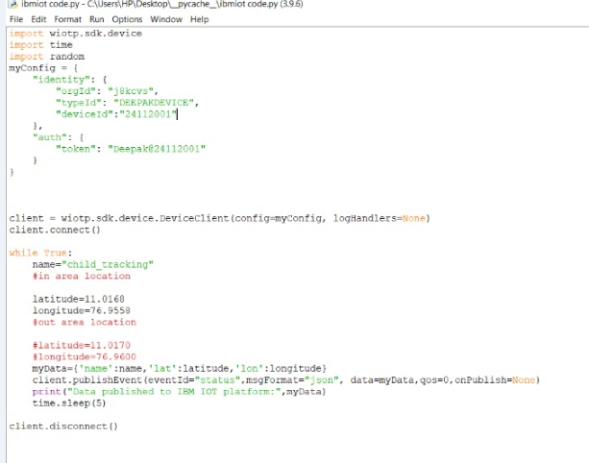

**b. UI output Screenshot**

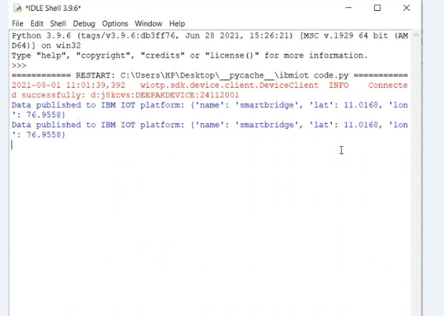

**NODE RED-FLOW:**

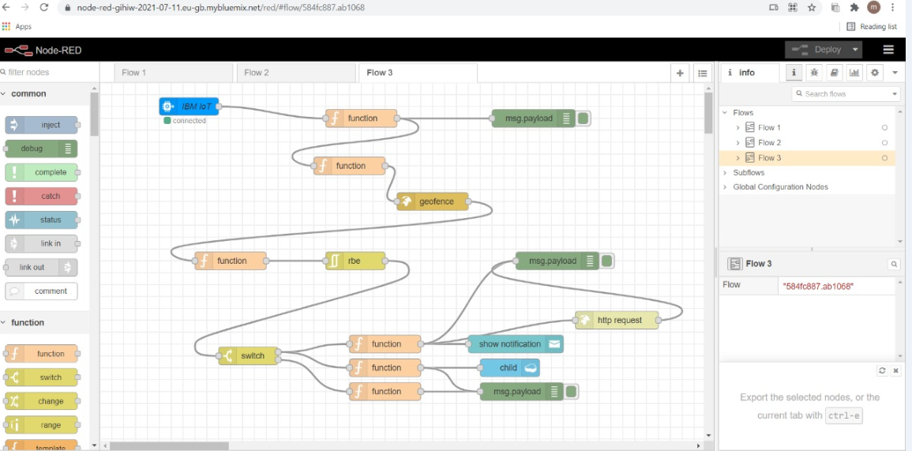

**Function node -1:**

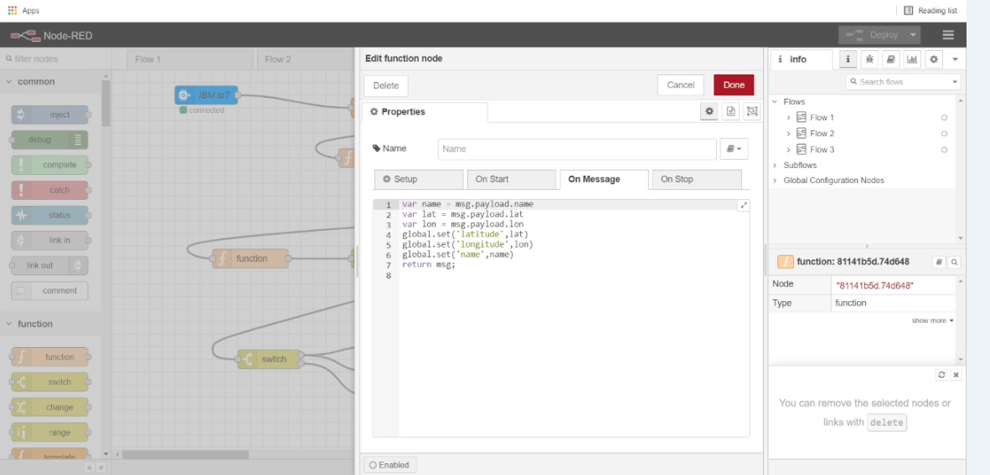

**Function node-2:**

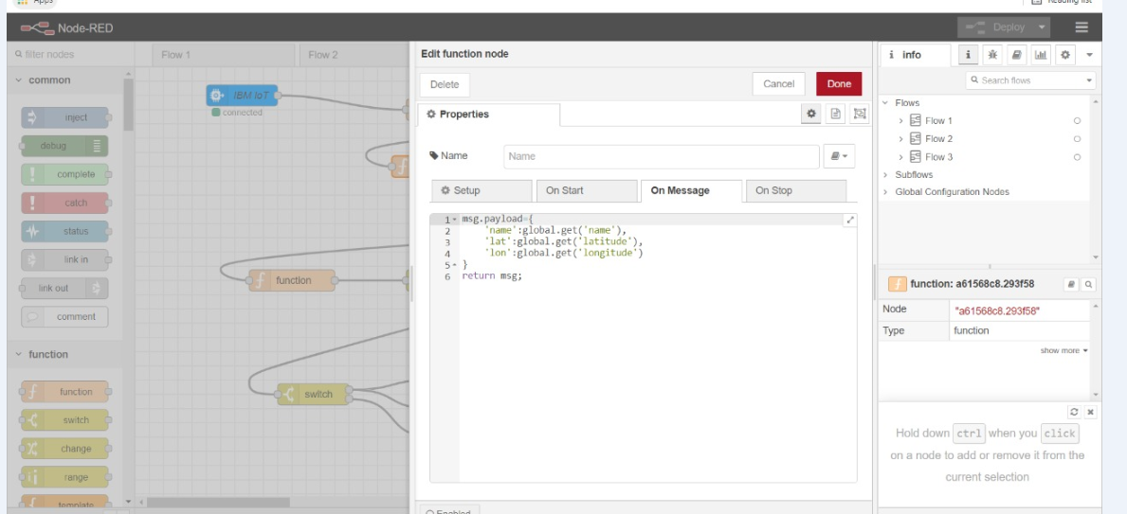

**Function node-3:**

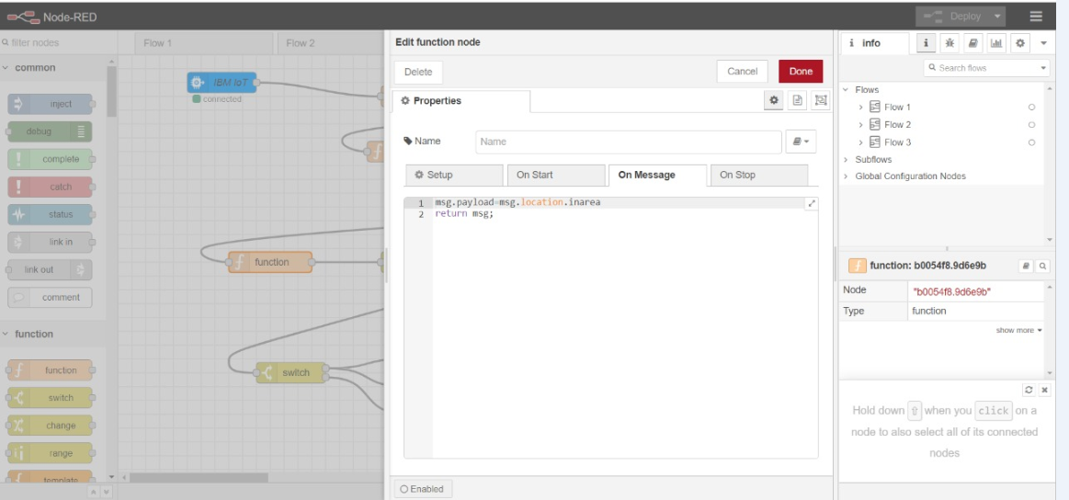

**Switch function block:**

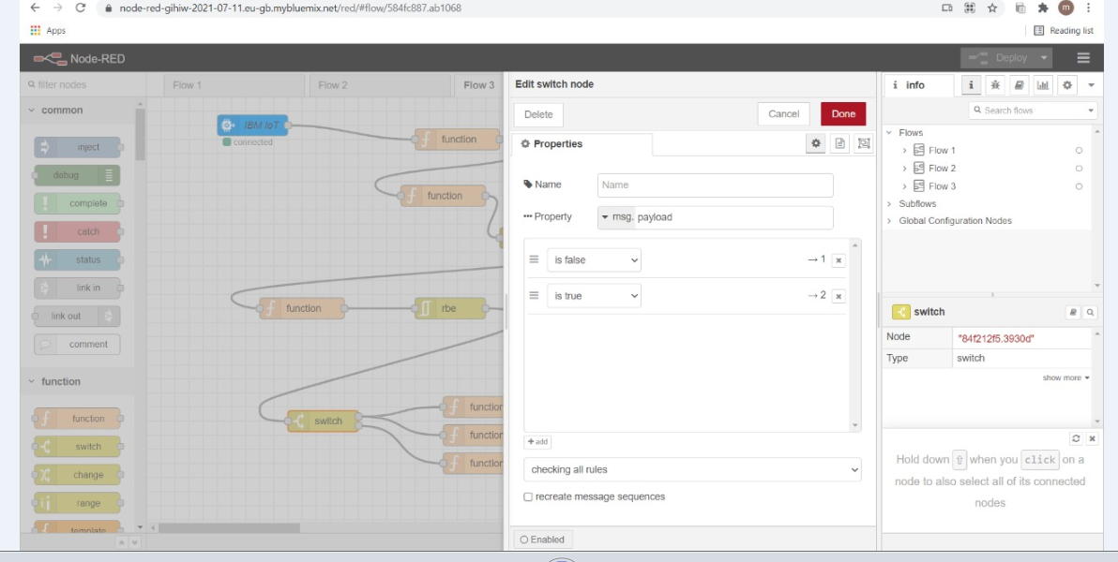

**Function node-4:**

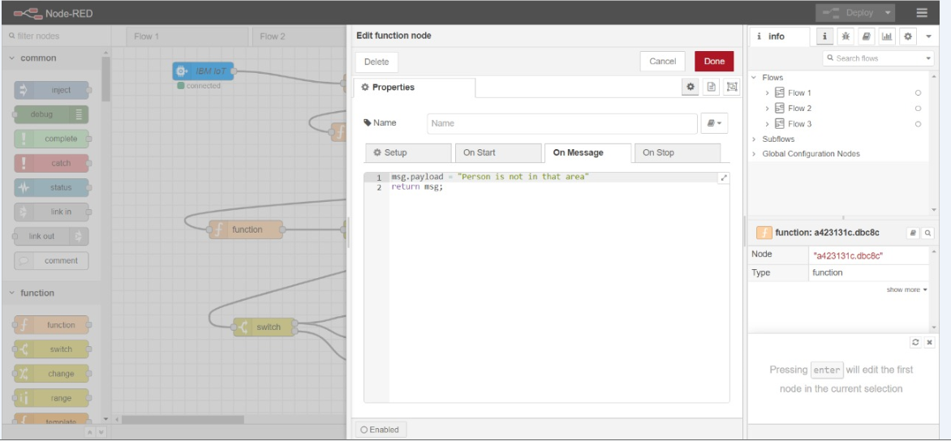

**Function node-5:**

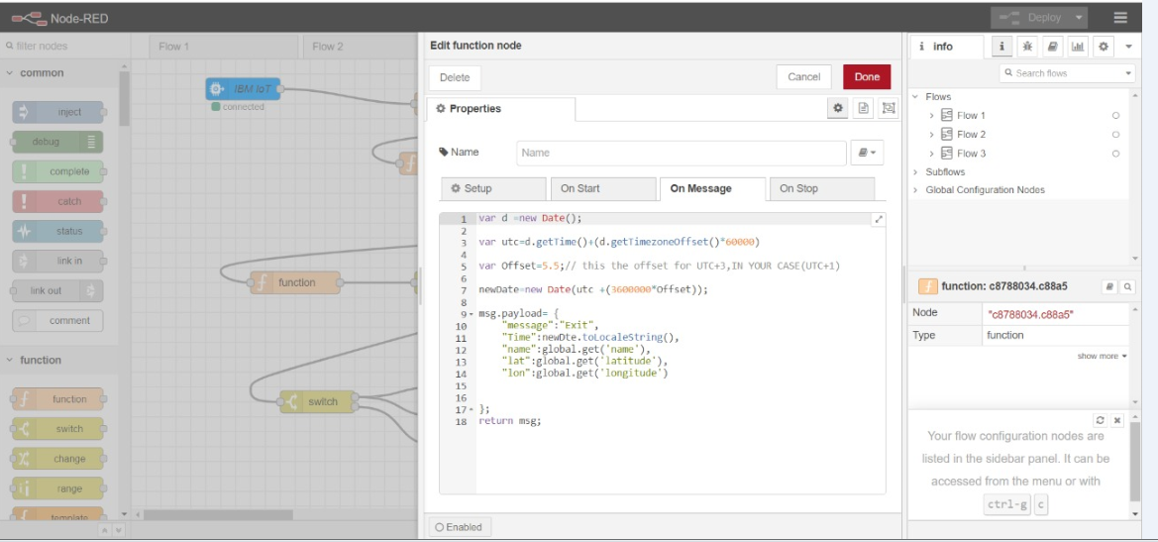

**Function node-6:**

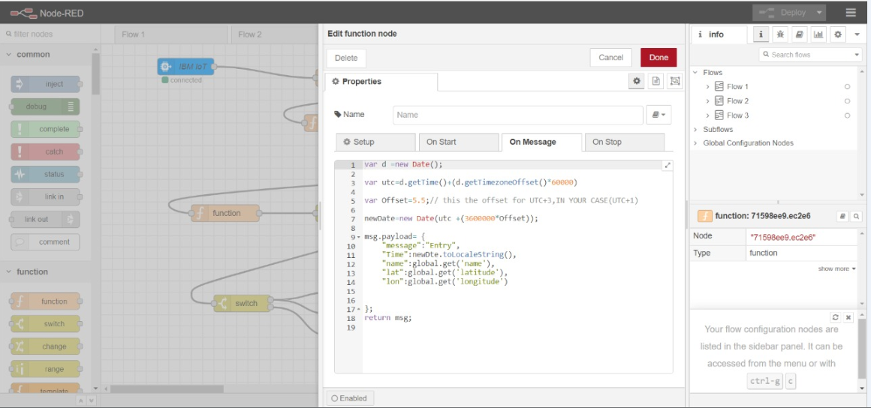

**http request node:**

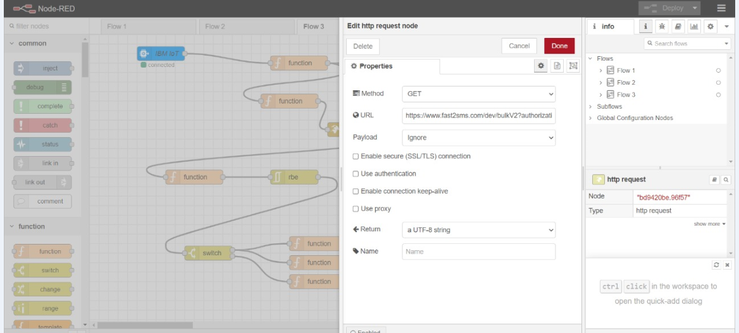

**Fast 2sms:**

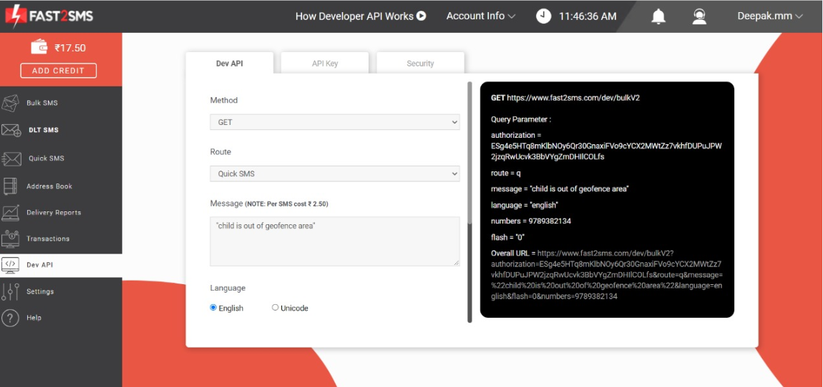

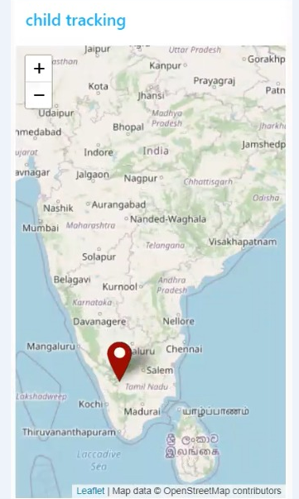

**Geofence:**